# The App-Owns-Data Starter Kit

The  **App-Owns-Data Starter Kit** is a developer sample built using the .NET 5 SDK to provide guidance for organizations and ISVs who are using App-Owns-Data embedding with Power BI in a multi-tenant environment. This solution consists of a custom database and three separate web applications which demonstrate common design patterns when developing with the App-Owns-Data embedding model such as creating new Power BI workspaces for tenants, assigning user permissions and monitoring report usage and performance.

If you have worked with Azure AD, the word **"tenant"** might make you think of an Azure AD tenant. However, the concept of a tenant is different when designing a multi-tenant environment for App-Owns-Data embedding. In this context, each tenant represents a customer with one or more users for which you are embedding Power BI reports. In a multi-tenant environment, you must create a separate tenant for each customer. Provisioning a new customer tenant in a Power BI embedding solution typically involves writing code which programs the Power BI REST API to create a Power BI workspace, assign the workspace to a dedicated capacity, import PBIX files, patch datasource credentials and start dataset refresh operations.

There is a critical aspect to the App-Owns-Data embedding model that must be addressed in your initial application design. A distinct advantage of App-Owns-Data embedding is that you pay Microsoft by licensing dedicated capacities instead of by licensing individual users. This allows organizations and ISVs to reach users that remain completely unknown to Power BI.

So, here's the rub. If Power BI doesn’t know anything about your users, Power BI cannot really provide any assistance when it comes to authorization and determining which users should have access to what content. This isn't a problem in a simplistic scenario where you intend to give every user the exact same access to content. However, it's far more common that your application requirements will define authorization policies to determine which users have access to which customer tenants. Furthermore, if you're planning to take advantage of the Power BI embedding support for report authoring, you'll also need to implement an authorization scheme that allows an administrator to assign permissions to users with a granularity of view permissions, edit permissions and content creation permissions.

There are three key observation about developing with the App-Owns-Data embedding model. First, you have the flexibility to design the authorization scheme for your application any way you'd like. Second, you have the responsibility to design and implement this authorization scheme from the ground up. Third, your solution should include a custom database to track whatever data and metadata you need to design and implement the authorization policies and enforcement you require.

The **App-Owns-Data Starter Kit solution** provides a starting point when developing with App-Owns-Data embedding and demonstrates how to implement the following application requirements.

* Onboarding new customer tenants
* Managing user permissions
* Implementing the customer-facing client as a Single Page Application (SPA)
* Creating a custom telemetry layer to log user activity
* Monitoring user actions such as ViewReport, EditReport and CreateReport
* Monitoring the performance of report loading and rendering

## Solution Architecture

The **App-Owns-Data Starter Kit** solution is built on top of a custom SQL Server database named **AppOwnsDataDB**. In addition to the **AppOwnsDataDB** database, the solution contains three Web application projects named **AppOwnsDataAdmin**, **AppOwnsDataWebApi** and **AppOwnsDataClient** as shown in the following diagram.

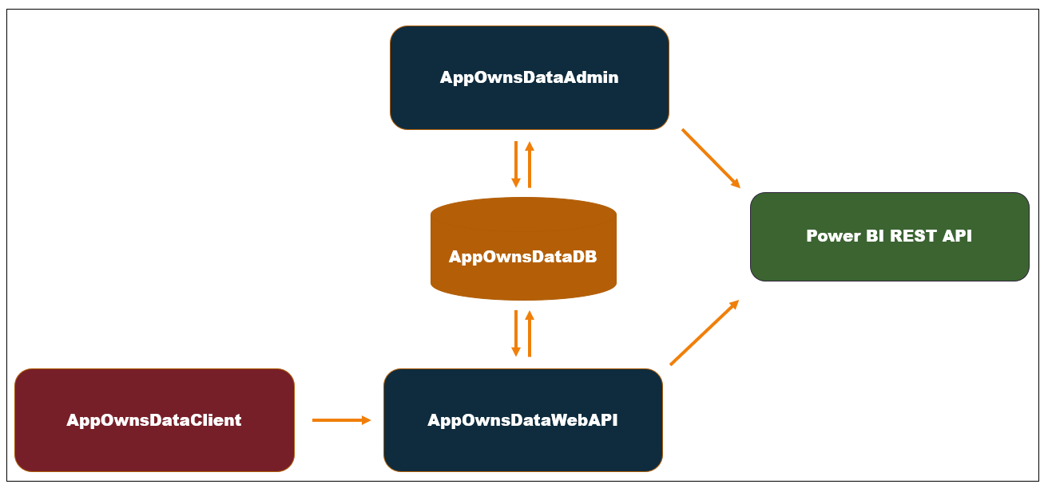

Here is a brief description of each of these web application

* **AppOwnsDataAdmin**: administrative application used to create new tenants and manage user permissions.
* **AppOwnsClient**: customer-facing SPA built using HTML, CSS and Typescript used to view and author reports.
* **AppOwnsDataWebApi**: custom Web API used by the **AppOwnsDataClient** application.

The **AppOwnsDataAdmin** application is what the hosting company uses to manage its multi-tenant environment. The **AppOwnsDataAdmin** application provides support to create new customer tenants which involves creating Power BI workspaces and importing PBIX files to create datasets and reports. The **AppOwnsDataAdmin** application also provides a UI experience for administrators at the hosting company with the ability to assign users to a customer tenant and to configure the assignment within a tenant with view permissions, edit permissions and create permissions.

The **AppOwnsDataClient** application is the web application used by customers to access embedded reports within a customer tenant. This application has been created as an SPA to provide the best reach across different browsers and to provide a responsive design for users accessing the application using a mobile device such as an iPhone or a small tablet.

The **AppOwnsDataWebApi** xxxxx

The **AppOwnsDataShared** project

You can follow the steps in this document to set up the **App-Owns-Data Starter Kit** solution for testing. To complete these steps, you will require a Microsoft 365 tenant in which you have permissions to create and manage Azure AD applications and security groups. You will also need Power BI Service administrator permissions to configure Power BI settings to give the service principal for an Azure AD application to ability to access the Power BI Service API. If you do not have a Microsoft 365 environment for testing, you can create one for free by following the steps in [Create a Development Environment for Power BI Embedding](https://github.com/PowerBiDevCamp/Camp-Sessions/raw/master/Create%20Power%20BI%20Development%20Environment.pdf).

## Set up your development environment

To set up the  **App-Owns-Data Starter Kit** solution for testing, you will need to configure a Microsoft 365 environment by completing the following tasks.

* Create an Azure AD security group named Power BI Apps
* Configure Power BI tenant-level settings for service principal access
* Create the Azure AD Application for the AppOwnsDataAdmin Application

The following three sections will step through each of these setup tasks.

### Create an Azure AD security group named Power BI Apps

Begin by navigating to the [Groups management page](https://portal.azure.com/#blade/Microsoft_AAD_IAM/GroupsManagementMenuBlade/AllGroups) in the Azure portal. Once you get to the **Groups** page in the Azure portal, click the **New group** link.

](https://github.com/PowerBiDevCamp/TenantManagement/blob/main/Images/ReadMe/media/image1.png)

In the **New Group** dialog, Select a **Group type** of **Security** and enter a **Group name** of **Power BI Apps**. Click the **Create** button to create the new Azure AD security group.

](https://github.com/PowerBiDevCamp/TenantManagement/blob/main/Images/ReadMe/media/image2.png)

Verify that you can see the new security group named **Power BI Apps** on the Azure portal **Groups** page.

](https://github.com/PowerBiDevCamp/TenantManagement/blob/main/Images/ReadMe/media/image3.png)

### Configure Power BI tenant-level settings for service principal access

Next, you need you enable a tenant-level setting for Power BI named **Allow service principals to use Power BI APIs**. Navigate to the Power BI Service admin portal at <https://app.powerbi.com/admin-portal>. In the Power BI Admin portal, click the **Tenant settings** link on the left.

](https://github.com/PowerBiDevCamp/TenantManagement/blob/main/Images/ReadMe/media/image4.png)

Move down in the **Developer settings** section and expand the **Allow service principals to use Power BI APIs** section.

](https://github.com/PowerBiDevCamp/TenantManagement/blob/main/Images/ReadMe/media/image5.png)

Note that the **Allow service principals to use Power BI APIs** setting is initially set to **Disabled**.

](https://github.com/PowerBiDevCamp/TenantManagement/blob/main/Images/ReadMe/media/image6.png)

Change the setting to **Enabled**. After that, set the **Apply to** setting to **Specific security groups** and add the **Power BI Apps** security group as shown in the screenshot below. Click the **Apply** button to save your configuration changes.

](https://github.com/PowerBiDevCamp/TenantManagement/blob/main/Images/ReadMe/media/image7.png)

You will see a notification indicating it might take up to 15 minutes to apply these changes to the organization.

](https://github.com/PowerBiDevCamp/TenantManagement/blob/main/Images/ReadMe/media/image8.png)

Now scroll upward in the **Tenant setting** section of the Power BI admin portal and locate **Workspace settings**.

](https://github.com/PowerBiDevCamp/TenantManagement/blob/main/Images/ReadMe/media/image9.png)

Note that a new Power BI tenant has an older policy where only users who have the permissions to create Office 365 groups can create new Power BI workspaces. You must reconfigure this setting so that service principals in the **Power BI Apps** group will be able to create new workspaces.

](https://github.com/PowerBiDevCamp/TenantManagement/blob/main/Images/ReadMe/media/image10.png)

In **Workspace settings**, set **Apply to** to **Specific security groups, add the Power BI Apps security group and** click the **Apply** button to save your changes.

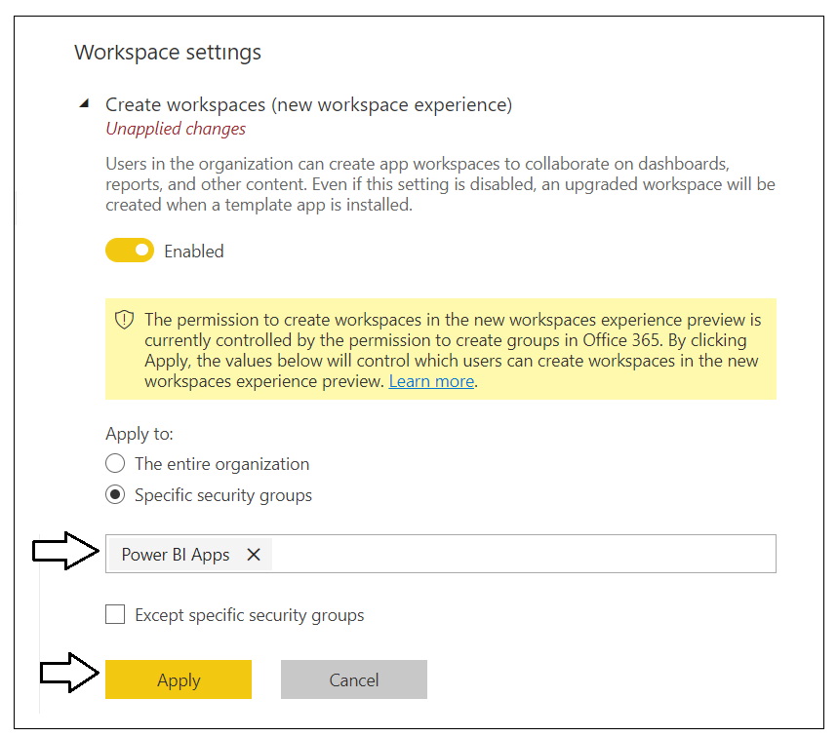

You have now completed the configuration of Power BI tenant-level settings.

### Create the ****App-Owns-Data Service App in Azure AD****

Login to the Azure portal to create the new Azure AD application. Begin by navigating to the [App registration](https://portal.azure.com/#blade/Microsoft_AAD_IAM/ActiveDirectoryMenuBlade/RegisteredApps) page in the Azure portal and click the **New registration** link.

](https://github.com/PowerBiDevCamp/TenantManagement/blob/main/Images/ReadMe/media/image12.png)

On the **Register an application** page, enter an application name of **App-Owns-Data Service App** and accept the default selection for **Supported account types** of **Accounts in this organizational directory only**.

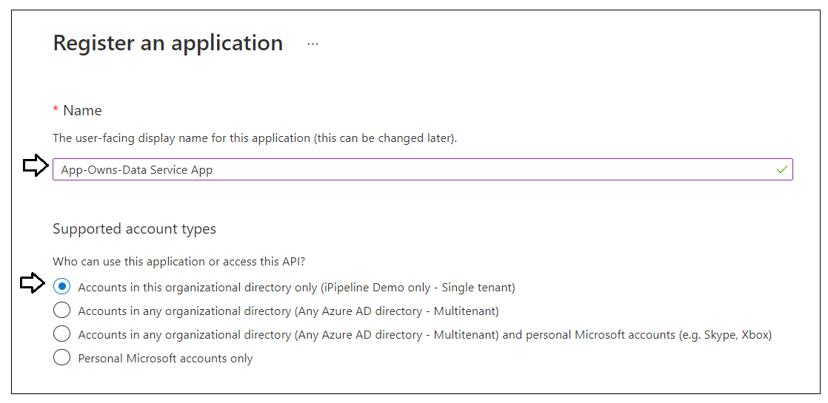

Complete the following steps in the **Redirect URI** section.

1. Leave the default selection of **Web** in the dropdown box
2. Enter a **Redirect URI** of [**https://localhost:44300/signin-oidc**](https://localhost:44300/signin-oidc)
3. Click the **Register** button to create the new Azure AD application.

](https://github.com/PowerBiDevCamp/TenantManagement/blob/main/Images/ReadMe/media/image14.png)

After creating a new Azure AD application in the Azure portal, you should see the Azure AD application overview page which displays the **Application ID**. Note that the ***Application ID*** is often called the ***Client ID***, so don't let this confuse you. You will need to copy this Application ID and store it so you can use it later to configure the project's support for Client Credentials Flow.

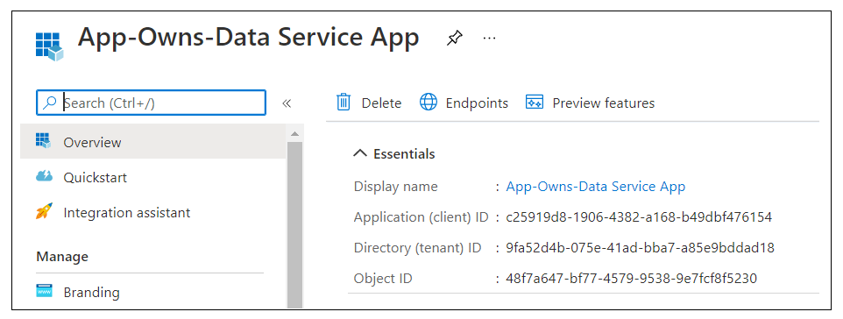

Copy the **Client ID** (aka Application ID) and paste it into a text document so you can use it later in the setup process. Note that this **Client ID** value will be used by **AppOwnsDataAdmin** project and the **AppOwnsDataWebApi** project to configure authentication with Azure AD.

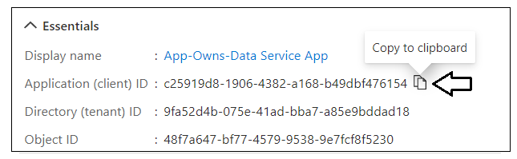

Next, repeat the same step by copying the **Tenant ID** and copying that into the text document as well.

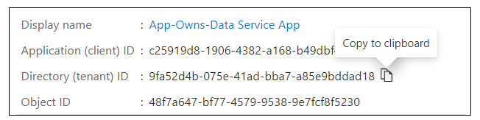

Your text document should now contain the **Client ID** and **Tenant ID** as shown in the following screenshot.

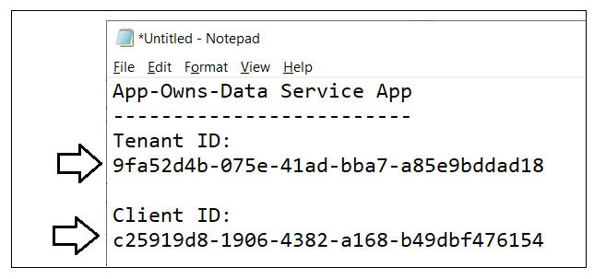

Next, you need to create a Client Secret for the application. Click on the **Certificates & secrets** link in the left navigation to move to the **Certificates & secrets** page. On the **Certificates & secrets** page, click the **New client secret** button as shown in the following screenshot.

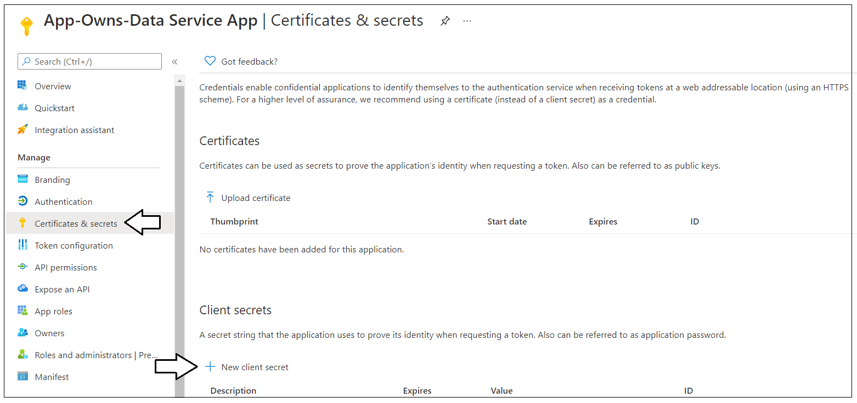

In the **Add a client secret** dialog, add a text description such as **Test Secret** and then click the **Add** button to create the new Client Secret.

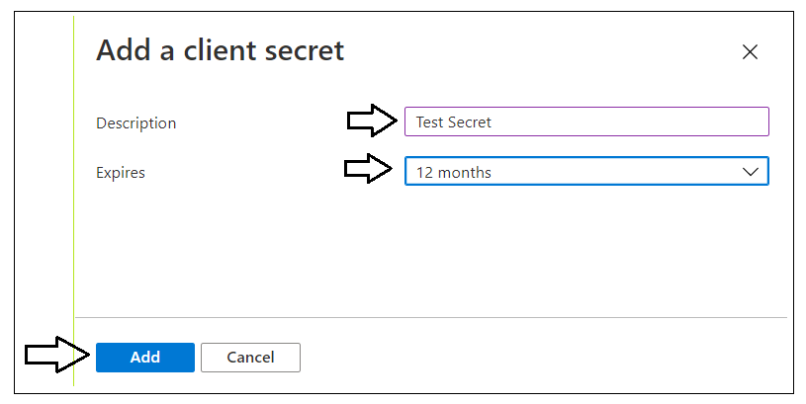

Once you have created the Client Secret, you should be able to see its **Value** in the **Client secrets** section. Click on the **Copy to clipboard** button to copy the Client Secret into the clipboard.

](https://github.com/PowerBiDevCamp/TenantManagement/blob/main/Images/ReadMe/media/image21.png)

Paste the **Client Secret** into the same text document with the **Client ID** and **Tenant ID**.

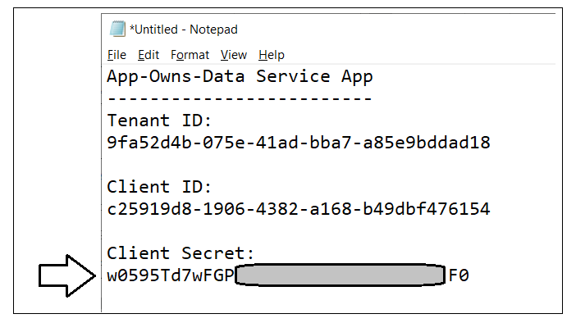

Last thing is to add the service principal for this app to Azure AD Security group named Power BI Apps.

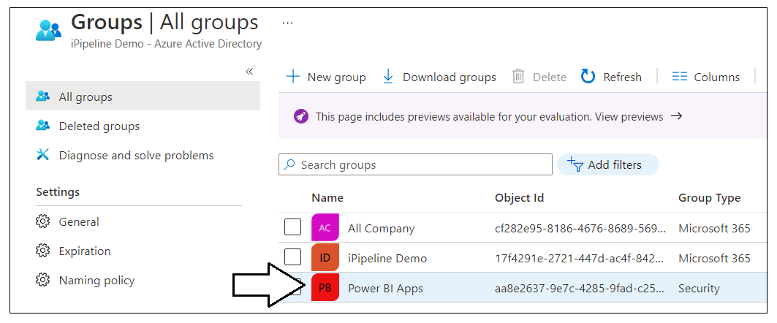

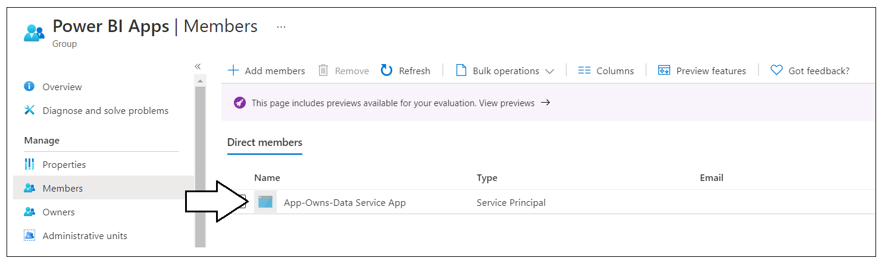

### Create the Azure AD Application for the ****App-Owns-Data Client App****

Login to the Azure portal to create the new Azure AD application. Begin by navigating to the [App registration](https://portal.azure.com/#blade/Microsoft_AAD_IAM/ActiveDirectoryMenuBlade/RegisteredApps) page in the Azure portal and click the **New registration** link.

](https://github.com/PowerBiDevCamp/TenantManagement/blob/main/Images/ReadMe/media/image12.png)

On the **Register an application** page, enter an application name of **App-Owns-Data Client App** and change **Supported account types** to **Accounts in any organizational directory and personal Microsoft accounts**.

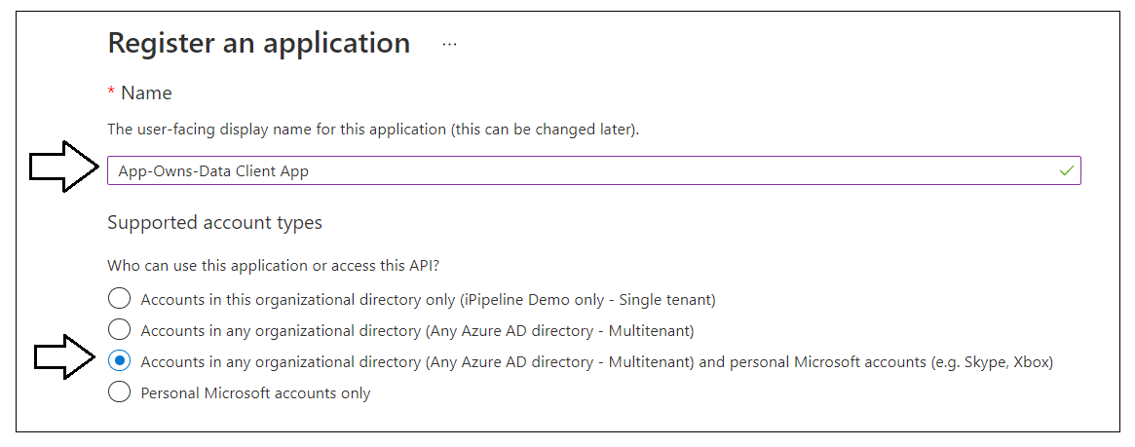

Complete the following steps in the **Redirect URI** section.

1. Leave the default selection of **Web** in the dropdown box
2. Enter a **Redirect URI** of [**https://localhost:44301/**](https://localhost:44301/).
3. Click the **Register** button to create the new Azure AD application.

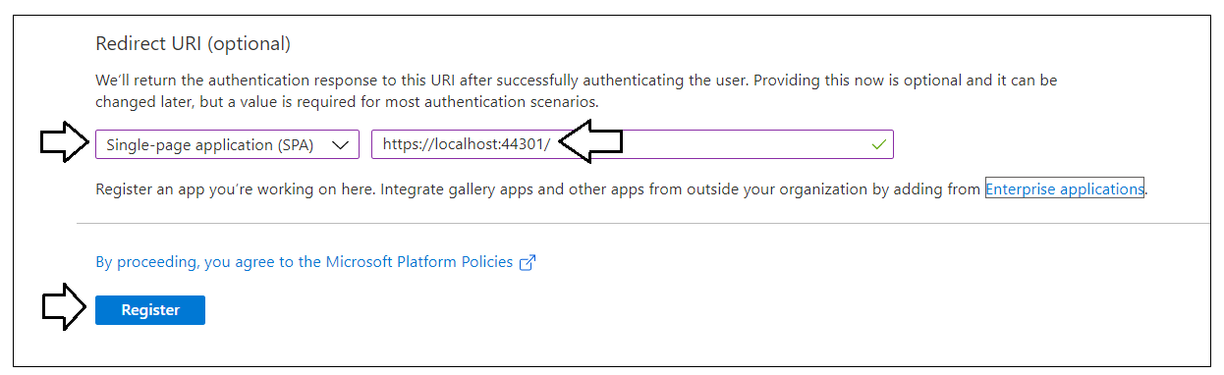

After creating a new Azure AD application in the Azure portal, you should see the Azure AD application overview page which displays the **Application ID**. Copy the **Client ID** (aka Application ID) and paste it into a text document so you can use it later in the setup process. Note that this **Client ID** value will be used by **AppOwnsDataClient** project and the **AppOwnsDataWebApi** project to configure authentication with Azure AD.

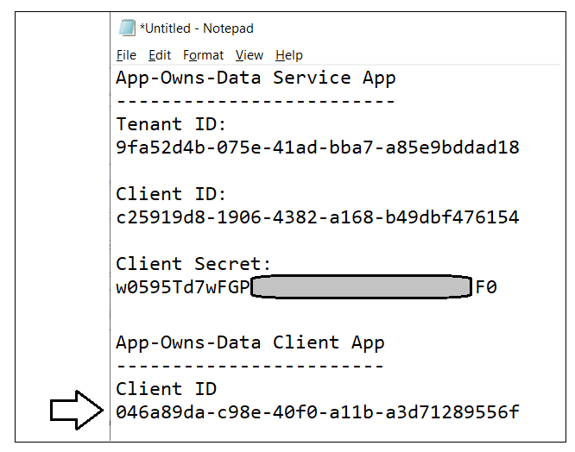

Expose an

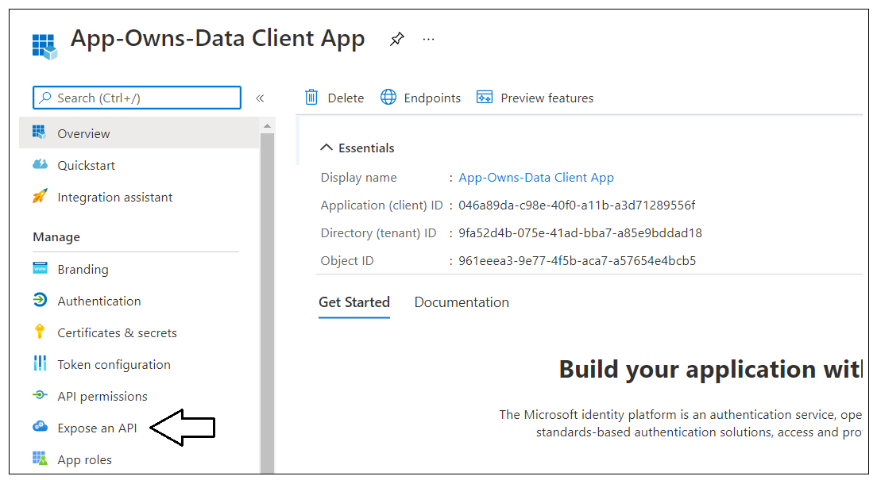

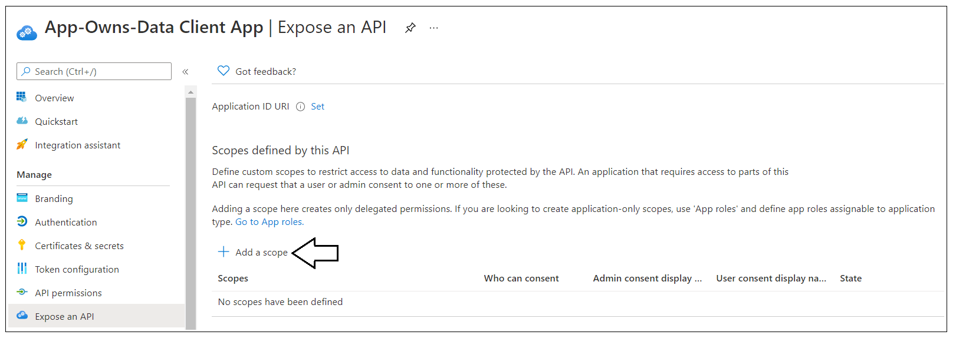

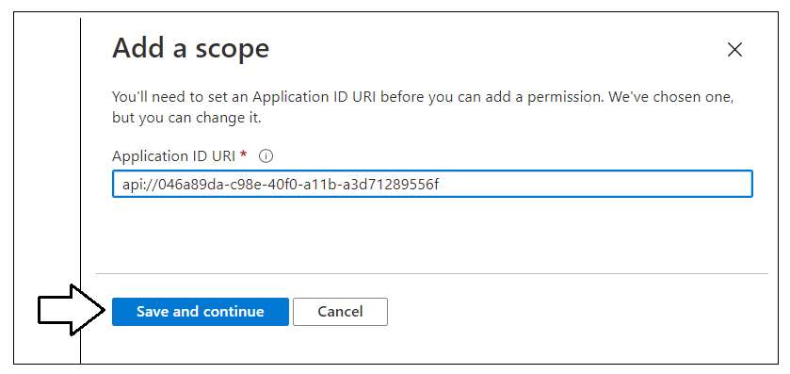

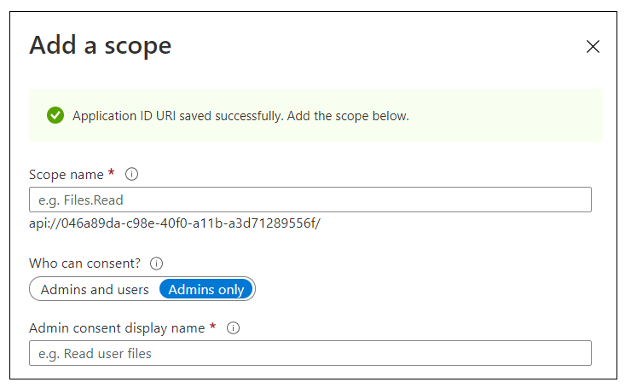

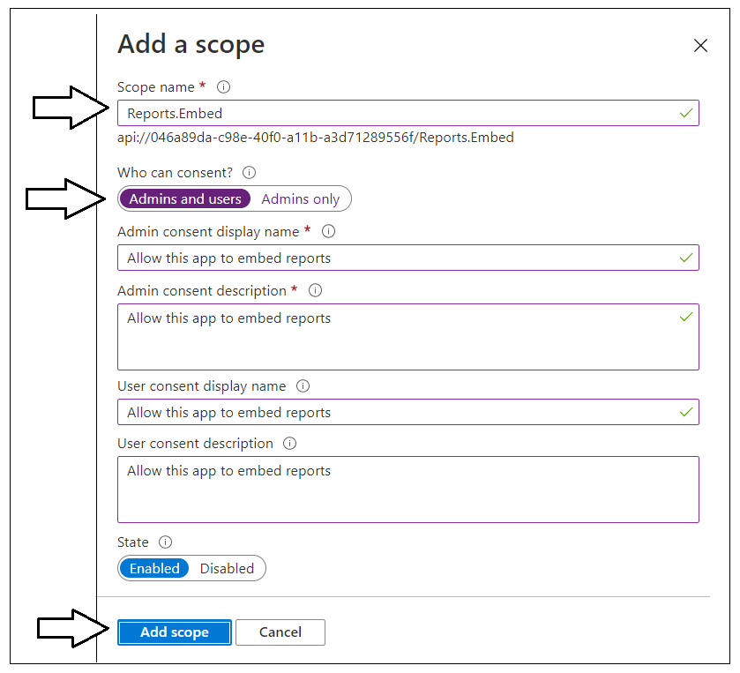

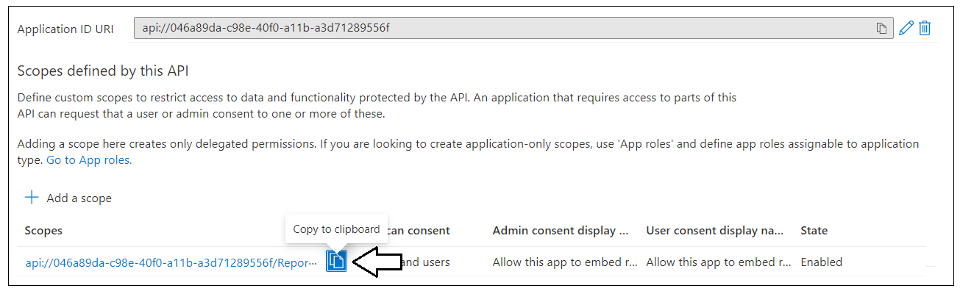

N n n n

api://046a89da-c98e-40f0-a11b-a3d71289556f/Reports.Embed

kkmkmkm

## Open he App-Owns-Data Starter Kit solution in Visual Studio 2019

In order to run and test the **AppOwnsDataAdmin** project on a developer workstation, you must install the .NET 5 SDK and Visual Studio 2019. While this document will walk through the steps of opening and running the **AppOwnsDataAdmin** project using Visual Studio 2019, you can also open and run the project using Visual Studio Code if you prefer that IDE. Here are links to download this software if you need them.

1. .NET 5 SDK – [[download](https://dotnet.microsoft.com/download/dotnet/5.0)]
2. Visual Studio 2019 – [[download](https://visualstudio.microsoft.com/downloads/)]
3. Visual Studio Code – [[download](https://code.visualstudio.com/Download)]

### Download the Source Code

The source code for the **App-Owns-Data Starter Kit solution** is maintained in a GitHub repository at the following URL.

<https://github.com/PowerBiDevCamp/App-Owns-Data-Starter-Kit>

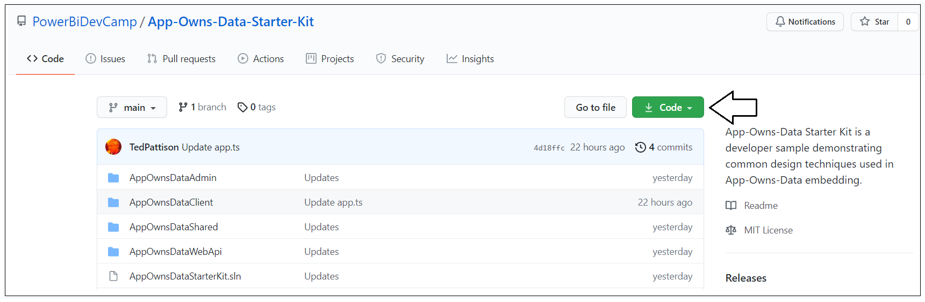

You can download the **AppOwnsDataAdmin** project source files in a single ZIP archive using [this link](https://github.com/PowerBiDevCamp/App-Owns-Data-Starter-Kit/archive/refs/heads/main.zip).

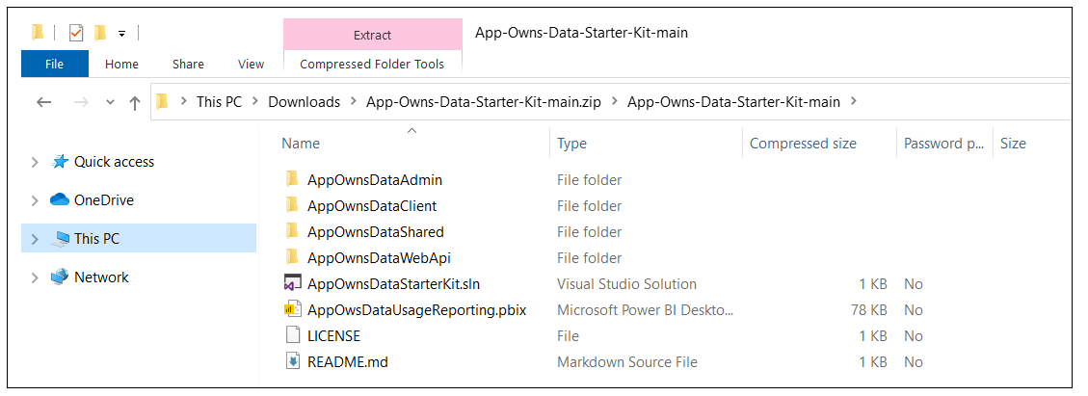

If you are familiar with the **git** utility, you can clone the project source files to your local developer workstation using the following **git** command.

**git clone https://github.com/PowerBiDevCamp/App-Owns-Data-Starter-Kit.git**

Once you have downloaded the source files for the **App-Owns-Data Starter Kit** solution to your developer workstation, you will see there is a top-level solution folder named **AppOwnsDataStarterKit** which contains child folders for four projects named **AppOwnsDataAdmin**, **AppOwnsClient**, **AppOwnsDataShared** and **AppOwnsDataWebApi**. You can open the Visual Studio solution containing all four projects by double-clicking the solution file named **AppOwnsDataStarterKit.sln**.

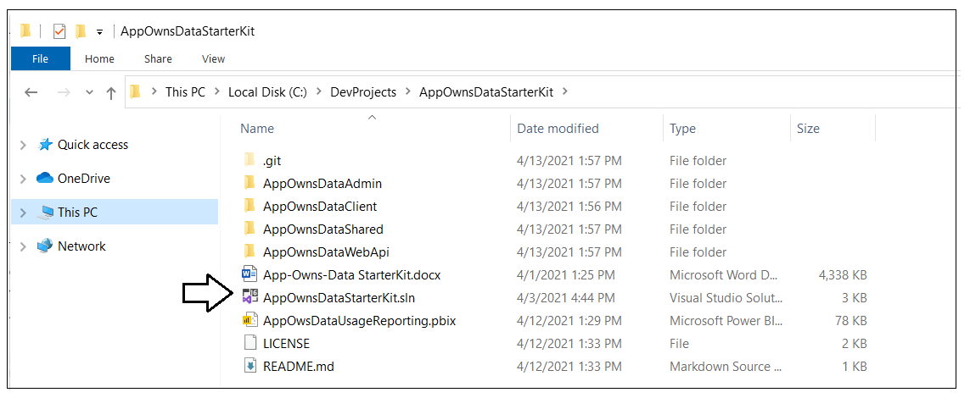

### Open the Solution in Visual Studio 2019

Launch Visual Studio 2019 and use the **File > Open > Project/Solution** menu command to open the solution file named **AppOwnsDataStarterKit.sln**. You should see the four child projects named **AppOwnsDataAdmin**, **AppOwnsClient**, **AppOwnsDataShared** and **AppOwnsDataWebApi**.

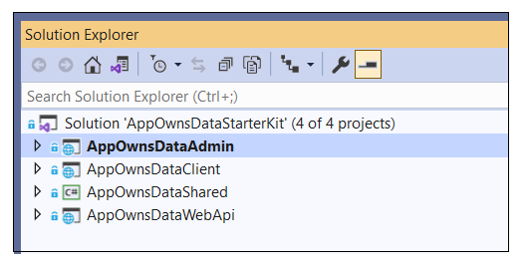

Here is a brief description of each of these projects.

* **AppOwnsDataAdmin**: An ASP.NET MVC Web Application built using .NET 5
* **AppOwnsClient**: A single page application built using HTML, CSS and Typescript
* **AppOwnsDataShared**: A class library project with Entry Framework code to generate the solution database named **AppOwnsDataDB**.
* **AppOwnsDataWebApi**: Custom Web API used AppOwnsData client to get embedding data and embed tokens.

### Update the appsettings.json file of AppOwnsDataAdmin project

Before you can run the application in the Visual Studio debugger, you must update several critical application settings in the **appsettings.json** file. Open the **appsettings.json** file and examine the JSON content inside. There is three important sections named **AzureAd**, **AppOwnsDataDB** and **DemoSettings**.

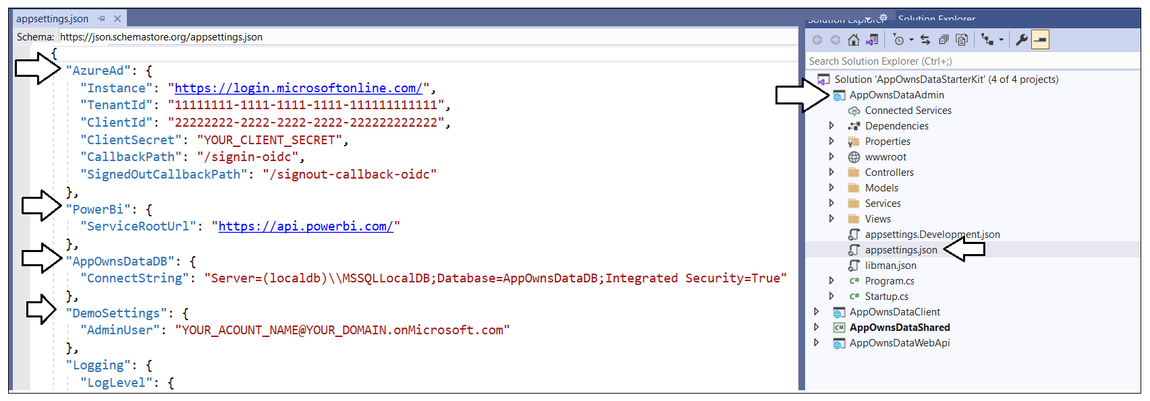

Inside the **AzureAd** section, update the **TenantId**, **ClientId** and **ClientSecret** with the data you collected when creating the Azure AD application named **Power BI Tenant Management Application.**

](https://github.com/PowerBiDevCamp/TenantManagement/blob/main/Images/ReadMe/media/image28.png)

If you are using Visual Studio 2019, you should be able leave the database connection string the way it is with the **Server** setting of **(localdb)\\MSSQLLocalDB**. You can change this connection string to point to a different server if you'd rather create the project database named **AppOwnsDataDB** in a different location.

](https://github.com/PowerBiDevCamp/TenantManagement/blob/main/Images/ReadMe/media/image29.png)

In the **DemoSettings** section there is a property named **AdminUser**. The reason that this property exists has to with you being able to see Power BI workspaces as they are created by service principals. There is code in the **AppOwnsDataAdmin** application that will add the user specified by the **AdminUser** setting as a workspace admin any times it creates a new Power BI workspace. This just makes things much easier for you to see what's going on when you begin to run and test the application.

Update the **AdminUser** setting with your Azure AD account name so that you will be able to see all the Power BI workspaces created by this application.

](https://github.com/PowerBiDevCamp/TenantManagement/blob/main/Images/ReadMe/media/image30.png)

### Create the ****AppOwnsDataDB**** database

Before you can run the application in Visual Studio, you must create the project database named **AppOwnsDataDB**. This database schema has been created using the .NET 5 version of the Entity Framework. In this step, you will execute two PowerShell cmdlets provided by Entity Framework to create the database.

Before creating the **AppOwnsDataDB** database, take a moment to understand how it’s been structured. Start by opening the file named **AppOwnsDataDB.cs** in the **Models** folder. Note that you shouldn't make any change to **AppOwnsDataDB.cs**. You are just going to inspect the file you understand how the **AppOwnsDataDB** database is generated.

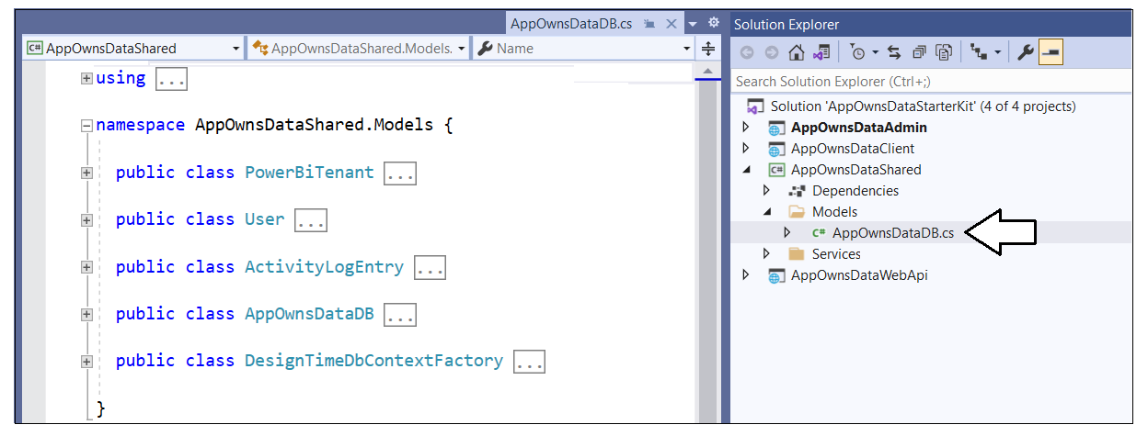

When you inspect the code inside **AppOwnsDataDB.cs**, you will see a class named **AppOwnsDataDB** that derives from **DbContext** to add support for automatic database generation using Entity Framework. The **AppOwnsDataDB** class serves as the top-level class for the Entity Framework which contains three  **DBSet** properties named **AppIdentites** and **Tenants**. When you generate the database, each of these **DBSet** properties will be created as database tables. The **AppIdentites** table is generated using the table schema defined by the **PowerBiAppIdentity** class.

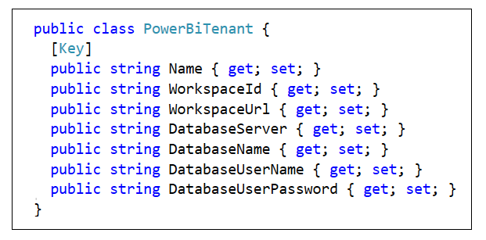

The **Tenants** table is generated using the table schema defined by the **PowerBiTenant** class.

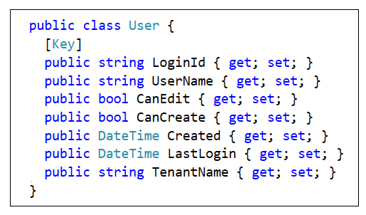

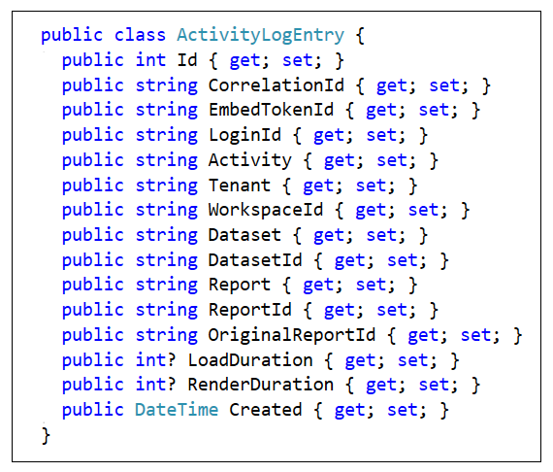

After you have inspected the code used to generated the database, close the source file named **AppOwnsDataDB.cs** without saving any changes. The next step is to run the PowerShell commands to create the project database named **AppOwnsDataDB**.

Open the Package Manager console using **Tools > NuGet Package Manager > Package Manager Console**.

](https://github.com/PowerBiDevCamp/TenantManagement/blob/main/Images/ReadMe/media/image34.png)

You should see the **Package Manager Console** command prompt where you can execute PowerShell commands.

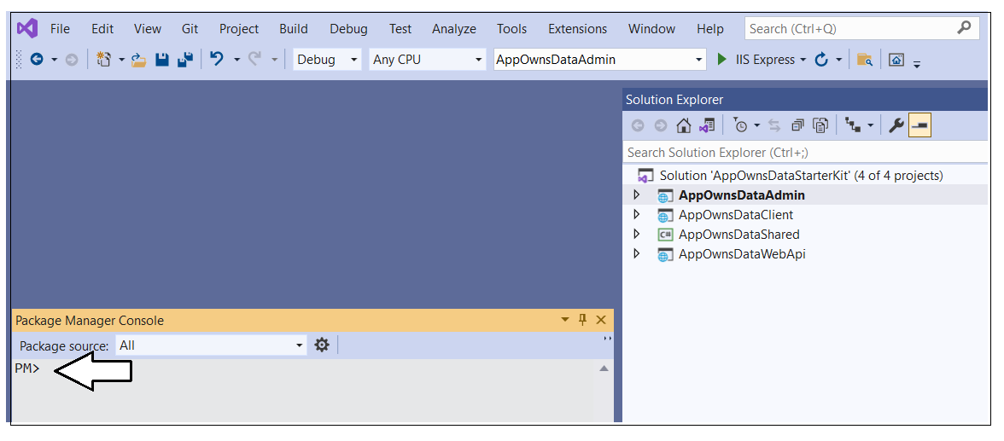

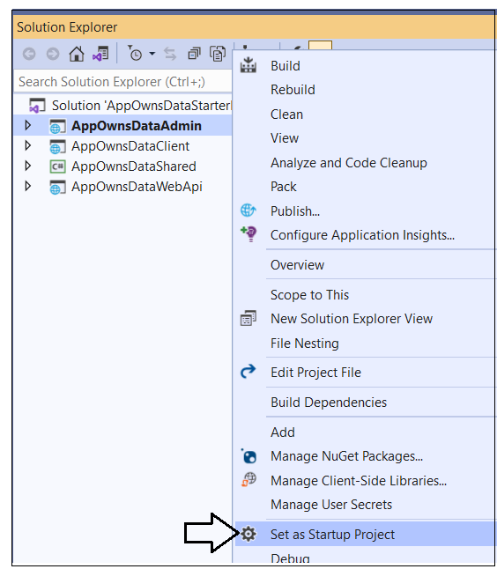

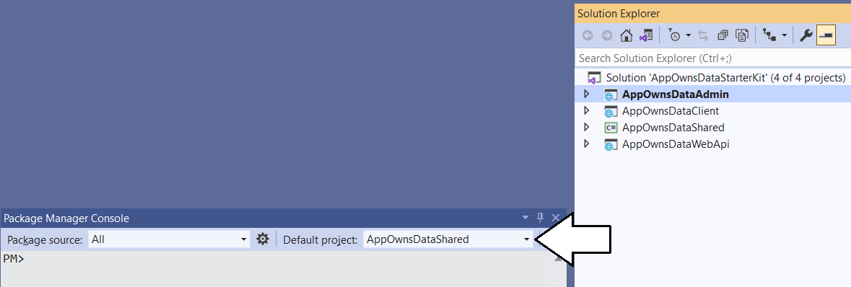

Type and execute the following **Add-Migration** command to create a new Entity Framework migration in the project.

Add-Migration InitialCreate

The **Add-Migration** command should run without errors. If this command fails you might have to modify the database connection string in **appsettings.json**.

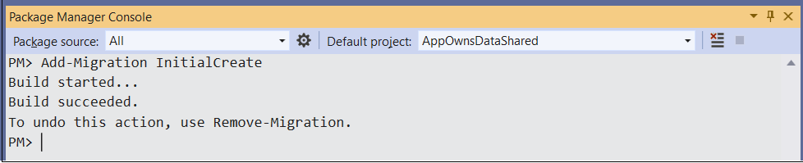

After running the Add-Migration command, you will see a new folder has been added to the project named **Migrations** with several C# source files. There is no need to change anything in thee source files but you can inspect what's inside them if you are curious how the Entity Framework does its work.

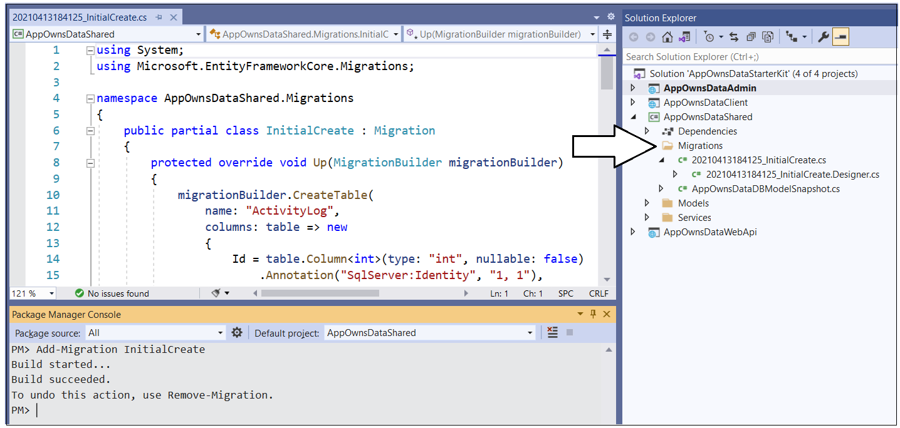

Return to the **Package Manager Console** and run the following **Update-Database** command to generate the database named **AppOwnsDataDB**.

Update-Database

The **Update-Database** command should run without errors and generate the database named **AppOwnsDataDB**.

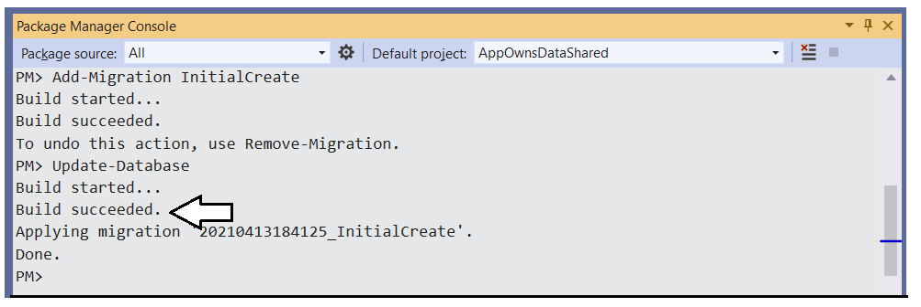

In Visual Studio, you can use the **SQL Server Object Explorer** to see the database that has just been created. Open the **SQL Server Object Explorer** by invoking the **View >** **SQL Server Object Explorer** menu command.

](https://github.com/PowerBiDevCamp/TenantManagement/blob/main/Images/ReadMe/media/image39.png)

Expand the **Databases** node for the server you are using and verify you an see the new database named **AppOwnsDataDB**.

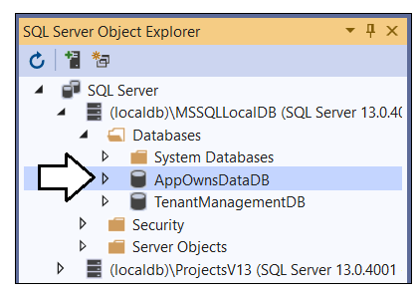

If you expand the **Tables** node for **AppOwnsDataDB**, you should see the two tables named **AppIdentities** and **Tenants**.

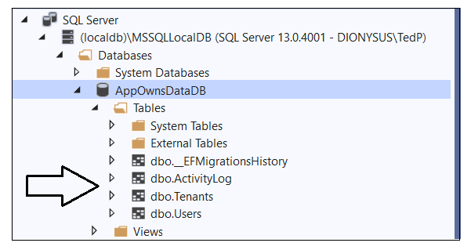

The **AppOwnsDataDB** database has now been set up and you are ready to run the application in the Visual Studio debugger.

## Test the AppOwnsDataAdmin Application

Launch the **AppOwnsDataAdmin** web application in the Visual Studio debugger by pressing the **{F5}** key or clicking the Visual Studio **Play** button with the green arrow and the caption **IIS Express**.

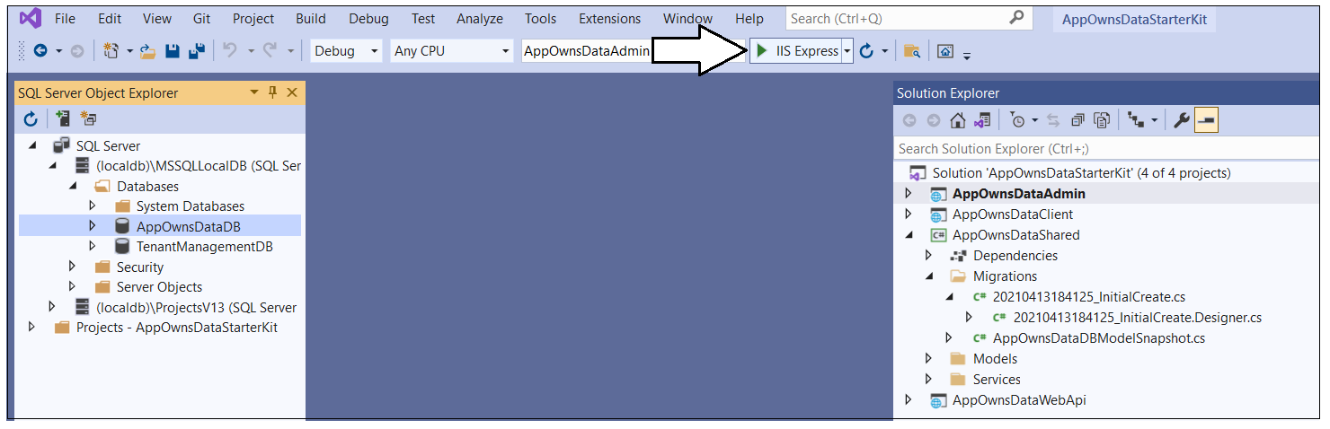

When the application starts, click the **Sign in** link in the upper right corner to begin the user login sequence.

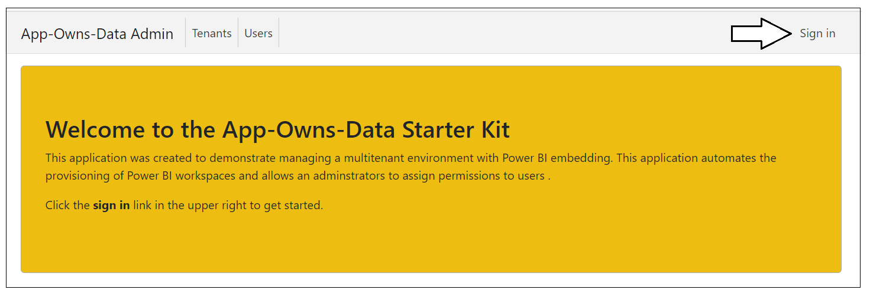

The first time you authenticate with Azure AD, you'll be prompted with the **Permissions requested** dialog asking you to accept the delegated permissions for the Microsoft Graph API requested by the application. Click the **Accept** button to grant these permissions and continue.

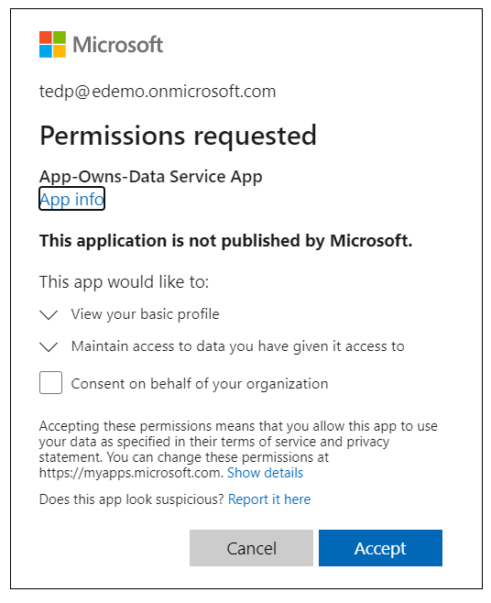

Once you have logged in, you should see your name in the welcome message.

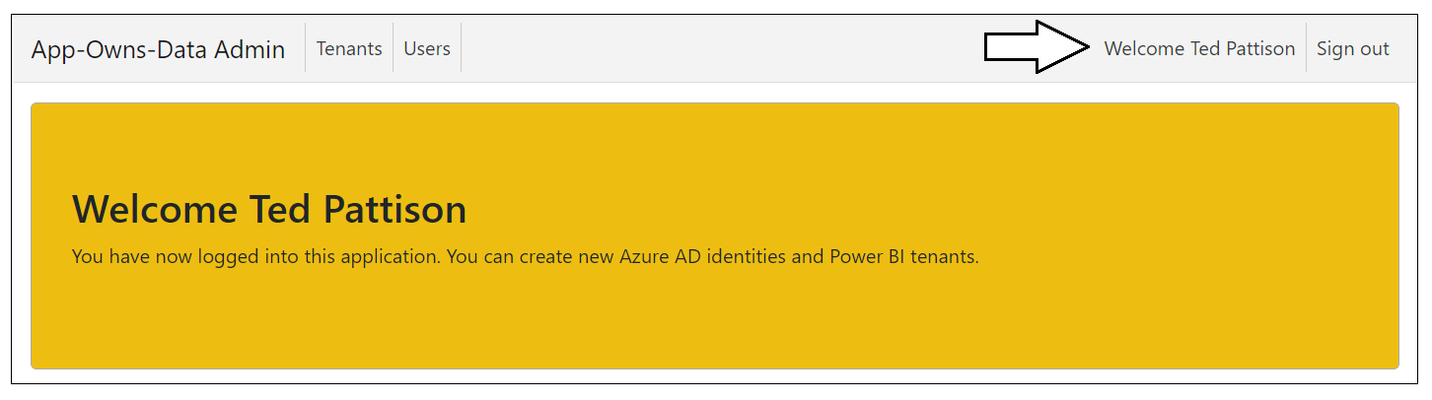

### Create New Customer Tenants

Start by creating a few new customer tenants. Click the **Tenants** link to navigate to the **Tenants** page.

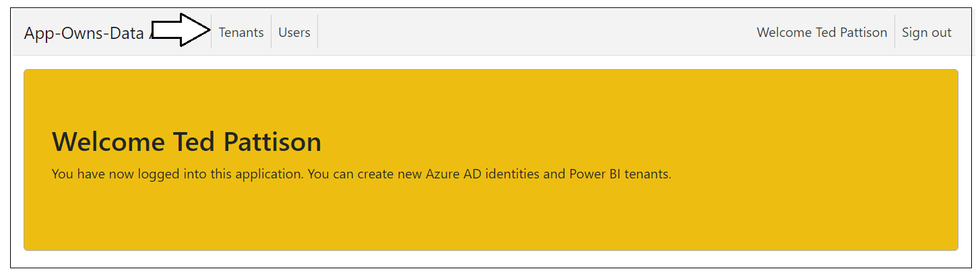

Click the **Onboard New Tenant** button to display the **Onboard New Tenant** page.

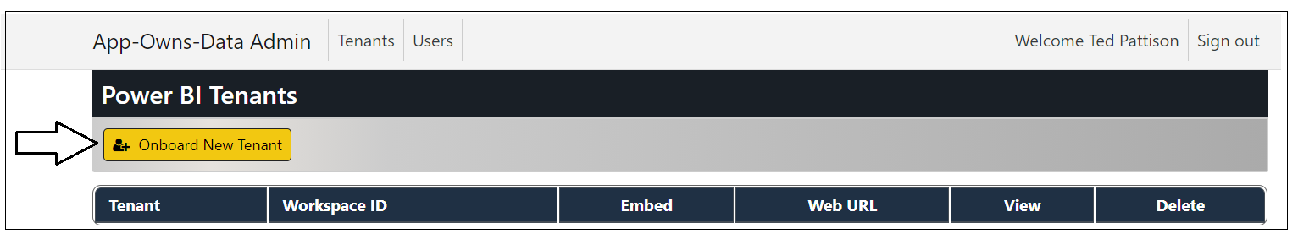

When you open the **Onboard New Tenant** page, it will automatically populate the **Tenant Name** textbox with a value of **Tenant01**. You can create the first tenant using the default values supplied by the **Onboard New Tenant** page or supply a different name. Click to **Create New Tenant** button to begin the process of creating a new customer tenant.

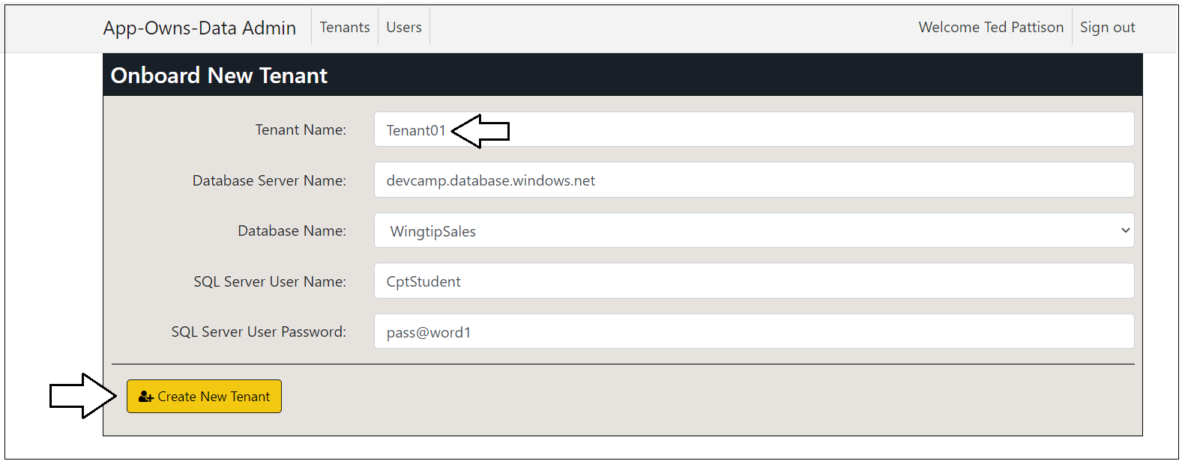

After a few seconds, you should see the new customer tenant has been created.

Click the **Onboard New Tenant** button again to create a second tenant.

This time, select a different database for **Database Name** and then click **Create New Tenant**.

](https://github.com/PowerBiDevCamp/TenantManagement/blob/main/Images/ReadMe/media/image59.png)

You should now have two customer tenants. Note they each tenant has a different app identity as its **Owner**.

Follow the same steps to create two more customer tenants.

Now let's discuss what's going on behind the scenes. As you create a new customer tenant, the **AppOwnsDataAdmin** application uses the Power BI REST API to implement the following onboarding logic.

1. Create a new Power BI workspace
2. Upload a [template PBIX file](https://github.com/PowerBiDevCamp/TenantManagement/raw/main/TenantManagement/wwwroot/PBIX/DatasetTemplate.pbix) to create the **Sales** dataset and the **Sales** report
3. Update dataset parameters on **Sales** dataset to point to this customer's database
4. Patch credentials for the SQL datasource used by the **Sales** dataset
5. Start a refresh operation on the **Sales** database

The **AppOwnsDataAdmin** application also create a new record in the **Tenants** table of the **AppOwnsDataDB** database. Note that the application identity associated with this customer tenant is tracked in the **Owner** column.

Click on the **View** button for a specific tenant on the **Power BI Tenants** page to drill into the **Tenant Details** page.

The **Tenant Details** page displays Power BI workspace details including its members, datasets and reports.

Click on the back arrow to return to the **Power BI Tenants** page.

If you're interested, you can examine the details of other tenants as well.

### Embed Reports

Now it's time to make use of the **AppOwnsDataAdmin** application's ability to embed reports. When navigate to the **Embed** page for a customer tenant, the **AppOwnsDataAdmin** application must acquire an access token for whichever app identity was used to create the customer tenant. The service principal that is configured as the **Owner** of a tenant will be the only service principal who will have access to access the target workspace in Power BI.

Move to the **Power BI Tenants** page and click on the **Embed** button for the first customer tenant.

You should now see a page with an embedded report for that tenant. When you click the **Embed** button to embed a report for a customer tenant, the **TenanantManagement** application retrieves credentials for the app identity associated with the tenant from the **AppOwnsDataDB** database. It then uses those credentials to acquire an access token from Azure AD using Client Credentials Flow. That access token is then used to communicate with the Power BI Service to retrieve report metadata and generate an embed token for the embedding process.

Click on the back arrow button to return to the **Tenants** page.

Now test clicking the **Embed** button for other customer tenants. As you can see, the **AppOwnsDataAdmin** application has the ability to acquire access tokens for any of the Azure AD applications that it has created.

### Inspect the Power BI Workspaces

If you're curious about what's been created in Power BI, you can see for yourself by navigating to the Power BI Service portal at [https://app.powerbi.com](https://app.powerbi.com/). You should be able to see and navigate to any of the Power BI workspaces that have been created by the **AppOwnsDataAdmin** application.

](https://github.com/PowerBiDevCamp/TenantManagement/blob/main/Images/ReadMe/media/image70.png)

Navigate to one of these workspaces such as **Tenant01**.

](https://github.com/PowerBiDevCamp/TenantManagement/blob/main/Images/ReadMe/media/image71.png)

Drill into the **Setting** page for the dataset named **Sales**.

](https://github.com/PowerBiDevCamp/TenantManagement/blob/main/Images/ReadMe/media/image72.png)

You should be able to verify that the **Sales** dataset has been configured by one of the Azure AD applications that was created by the **AppOwnsDataAdmin** application. You should also be able to see the **Last refresh succeeded** message for the dataset refresh operation that was started by the **AppOwnsDataAdmin** as part of its tenant onboarding logic.

](https://github.com/PowerBiDevCamp/TenantManagement/blob/main/Images/ReadMe/media/image73.png)

## Test the AppOwnsDataClient Application

xxxx

### Configure the WebAPI appsettings.

This concludes the walkthrough of the **AppOwnsDataAdmin** application.

### Configure the AppOwnsDataClient application

### Run the AppOwnsDataClient application

### Assign User Permissions

### Create and Edit Reports using AppOwnsDataClient

## Monitoring Usages and Report Performance using Activity Log

### Inspect the Usage Data in AppOwnsDataDB

### Inspect Usage Data using AppOwsDataUsageReporting.pbix